Appendix No.1
Apostille is always performed by the competent authority of the state in which the document was issued. Each authority issues an apostille for different types of documents, e.g.:
- registry documents – birth certificate, marriage certificate, death certificate are apostilled by the district office
- extracts from the criminal register, extract from the cadastre are apostilled by the Ministry of Foreign Affairs of the Slovak Republic
- the school leaving certificate and diploma are apostilled by the Ministry of Education of the Slovak Republic, and then a copy certified by a notary is made
- the self-employment certificate is issued by the district office and subsequently apostilled by the Public Administration section of the Ministry of the Interior of the Slovak Republic
- extracts from the commercial register are apostilled by the regional court
- official translations are apostilled by regional courts
- identity documents are first verified by a notary and subsequently apostilled at the regional court
- powers of attorney, affidavits and contracts are signed before a notary and subsequently apostilled at the regional court
- confirmations of permanent or temporary residence for citizens from Slovakia are apostilled at the district office
- certificates of permanent or temporary residence for citizens from abroad who live in Slovakia are first issued by the Foreign Police Department of the Slovak Republic and then apostilled by the Consular Department of the Ministry of Foreign Affairs of the Slovak Republic
- citizenship documents are apostilled by the Ministry of the Interior of the Slovak Republic
To avoid any inconveniences always check in advance which authority has the right to certify your document.
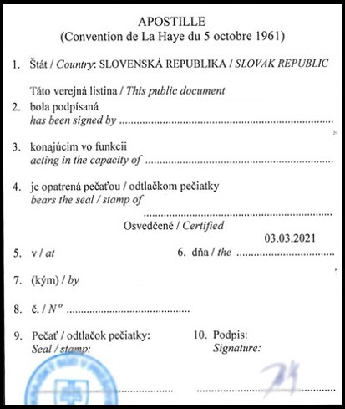
Example of the apostille in Slovakia:

